**Pre-Meeting Preparation for Maine AI Task Force for Thursday, March 13, 2025**

*Topic: Planning & Economic Implications*

In this memo, you’ll find a preview of the March 13 meeting agenda; a summary of findings from surveying the Task Force and proposed Task Force roadmap with small thematically organized subgroups; and background information for a presentation and discussion of AI’s economic implications for Maine. A new section at the end of the memo highlights recent stories about AI, including recent research publications and news from other states.[1]

**Meeting overview for March 13, 2025**

At the Task Force’s last meeting on February 14, 2025, Usama Fayyad of Northeastern’s Roux Institute presented on the current state of AI technologies; Cass Madison of the Center of Public Sector AI reviewed how other state governments are approaching AI; and Nishant Shah from Governor Moore’s administration summarized the State of Maryland’s work integrating AI into government operations. A recording of that meeting is available via [GOPIF’s YouTube channel](https://www.youtube.com/playlist?list=PLBsF3DHNFCaGJubo6l058pdLNp2SjdAn4).

The upcoming meeting on March 13 is designed to:

* *Planning:* Finalize roadmap for accomplishing the Task Force’s spring work.
* *Economic Implications:* Begin a discussion of AI’s economic implications for Maine and finalize questions to be assigned to the theme’s subgroup.

Agenda:

1. Welcome (5 min)
2. Review of results of Task Force Survey and discuss proposed Task Force roadmap (50 min)
   * See this prep memo for summary of survey results and proposed roadmap
3. Presentation on Maine’s 10-year economic strategy (20 min)
   * Phoenix McLaughlin, Director of Strategy Implementation, Maine Department of Economic and Community Development
4. Task Force Discussion (40 min)
   * Brief reflections on lessons from building an AI-enabled startup in Maine (Michael Odokara-Okigbo, [NKENNE](https://www.nkenne.com/)) and integrating AI into a research enterprise (Mary Dickinson, [The Jackson Laboratory](https://www.jax.org/))
   * Open discussion to finalize questions to be assigned to subgroup on AI’s economic implications for Maine. Proposed questions:
   1. *In what sectors does AI unlock opportunities for Maine to become a global innovation center?*
   2. *What steps could Maine take to facilitate additional AI-enabled innovation and business creation?*
   3. *What supports might Maine’s small businesses benefit from to explore and adopt AI tools?*
5. Wrap up (2 min)

*Post meeting:* GOPIF staff will reach out to individually to enable sign up for small group(s)

**Findings from survey of AI Task Force**

Task Force members and technical advisors were surveyed to inform the direction and structure of the Task Force’s work. Twenty responses were collected between Feb 14-24, 2025, which are summarized below. This input also formed the basis for a potential roadmap for the Task Force’s work, which will be discussed at the March 13 meeting.

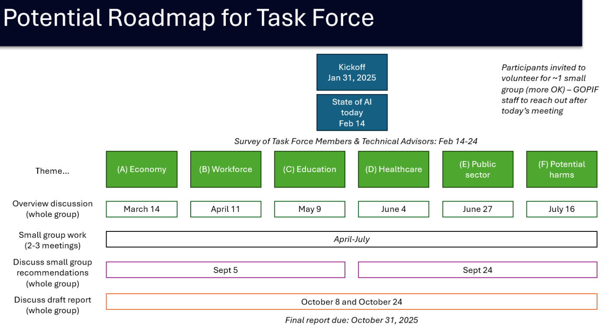

**Background on AI’s Economic Implications for Maine**

* [Maine’s 10-year Economic Plan](https://www.maine.gov/decd/strategic-plan): In 2019, the State embarked on its first strategic economic plan in two decades. This effort, which included over 1,500 voices in public meetings, online comments, and a diverse set of working group members, culminated in November 2019, when Governor Janet Mills released the State’s new 10-year strategic economic development plan. The plan was refreshed in 2024. The plan sets three goals – to increase wages by 10%, to increase the value of goods sold by 10%, and to grow Maine’s talent pool by 75,000 – to be accomplished through seven strategies: growing local talent; attracting new talent; promoting innovation; building broadband connectivity; providing supporting infrastructure; maintaining stable and predictable business rules; and promoting Hubs of Excellence. Read more at <https://www.maine.gov/decd/strategic-plan>.
* [The State of AI in Maine](https://ai.northeastern.edu/saim23): In 2023, Northeastern University's Institute for Experiential AI published "The State of AI Maine," a report that highlights artificial intelligence's growing role across five key industries in Maine: Healthcare & Life Sciences, Natural Resources, Education, Insurance & Financial Services, and Manufacturing. The report presents specific case studies, such as MaineHealth’s HE(ART) initiative using AI for real-time monitoring in intensive care units and IDEXX Laboratories deploying AI-powered veterinary diagnostics. Within Natural Resources, New England Marine Monitoring applies AI-driven image recognition to improve fish stock assessments, while UMaine utilizes AI for forest mapping and pest management. In Manufacturing, J.D. Irving's Ashland Sawmill is implementing AI for timber identification, optimizing efficiency in lumber production. Read more at <https://ai.northeastern.edu/saim23>.
* Maine Technology Institute (MTI)’s survey of early-stage company use of AI: In fall 2024, MTI surveyed 106 early-stage companies that had received funding. They found that half of companies were using AI tools in their business and, among those, most reported using AI multiple times per week and six firms reported that their business model was built around AI technologies. Only one of 106 respondents was not interested in applying AI in their business. Among firms not using AI, the three most common reported barriers were consistent: the cost of implementation, insufficient understanding of how AI could be applied to their business, and a lack of technical skills or resources. As a result of this work, MTI is exploring how to offer MTI clients low-cost access to AI training and assistance through its [Maine Entrepreneur Resource Corps program](https://www.mainetechnology.org/explore-funding-programs/maine-entrepreneur-resource-corps-merc/).

**AI in the News**

*General interest*

* [Ezra Klein interviews Ben Buchanan, the former special adviser for artificial intelligence in the Biden White House (New York Times Podcast)](https://www.nytimes.com/2025/03/04/opinion/ezra-klein-podcast-ben-buchanan.html): After initially covering national security implications of AI developments, the second half of the interview discusses policy responses to domestic impacts, including possible AI-driven worker displacement.
* Coverage of new AI model releases and developments, including the [New York Times on OpenAI’s release of its Deep Research AI agent tool](https://www.nytimes.com/2025/02/02/technology/openai-deep-research-tool.html) and [Axios on Manus AI, a new general-purpose AI agent tool developed in China](https://www.axios.com/2025/03/10/manus-chinese-ai-agent-deepseek).

*Research publications*

* [The geography of generative AI’s workforce impacts will likely differ from those of previous technologies (Brookings Institution):](https://www.brookings.edu/articles/the-geography-of-generative-ais-workforce-impacts-will-likely-differ-from-those-of-previous-technologies/) To explore the possible distribution of generative AI impacts across place, researchers build on earlier labor market analysis to leverage AI exposure statistics for occupations as they impact U.S. counties and metropolitan areas. They find the possible impact patterns of generative AI look quite different from those of previous forms of automation.
* [The Widespread Adoption of Large Language Model-Assisted Writing Across Society (Stanford University researchers)](https://arxiv.org/pdf/2502.09747): This new research paper finds widespread evidence of AI-assisted writing since 2022, including in 18% of financial consumer complaints, in 24% of corporate press releases, and in 10% of job postings by small firms. It also sees significant geographic distribution -- for example, among complaints to the Consumer Financial Protection Bureau, only 5.2% of complaints from Maine residents show evidence of Gen-AI assisted writing compared to 18% nationally. On this study, Wharton professor and AI commentator Ethan Mollick has observed, “[the past 18 months have seen the most rapid change in human written communication ever.](https://x.com/emollick/status/1895861786743881867)”

*AI and state government*

* [Oregon AI Advisory Council Unveils Its AI Action Plan (GovTech)](https://www.govtech.com/artificial-intelligence/oregon-ai-advisory-council-unveils-its-ai-action-plan): The Oregon State Government Artificial Intelligence Advisory Council has released its final action plan with 74 recommendations to guide government use of AI.
* [Nvidia has teamed up with Utah to improve AI education and workforce training (VentureBeat)](https://venturebeat.com/games/nvidia-has-teamed-up-with-utah-to-improve-ai-education-and-workforce-training/): Nvidia has teamed up with the state of Utah on an AI education initiative to improve workforce training and economic growth. The public-private partnership aims to equip universities, community colleges and adult education programs across Utah with the resources to develop skills in generative AI. See also [Banks Loan $2 Billion to Build a 100-Acre AI Data Center in Utah (WSJ)](https://www.wsj.com/real-estate/banks-loan-2-billion-to-build-a-100-acre-ai-data-center-in-utah-ca5e7e0d?st=KoHt2o).

##

1. Portions of this memo were drafted with assistance from GenAI technology.